THE KEYS 
Church of St. Peter the Apostle The Rev. Canon Peter Geromel, OHI, DMin - Rector
Anglican Catholic Diocese of the Mid-Atlantic States Sept/Oct 2025
www.dmas-acc.org www.anglicancatholic.org https://stpetersacc.org

The Rector’s Ramble New Sunday School Classes

Adults! This year we will be beginning a new topic for Sunday School for the Fall. Harold Kurstedt will hopefully be back with us for another session of his own after Christmas, but until then… Mike Slayton was kind enough to pick up a book Sunday School Lessons for 2025. The questions from that book will be used for group discussion along such topics as Who is God? Understanding His Attributes orWalking by Faith, Not by Sight. However, instead of the writeups in those chapters, we will mostly be using short texts from Christian Classics to inform and stimulate our discussion. This will follow the Fellowship time that follows the 10 AM service.

Children! We will also begin Sunday school for kids, using as our springboard, a Coptic Orthodox Sunday school program, which features many Western videos and culturally quite American. We will see how this goes and will, hopefully, begin each lesson with prayer from the Canadian Prayer Book’s Service for Young People. The children will also Bible texts to work on reading with word searches as their activity. This will be at 9:15 to 9:45 AM, between the two services.
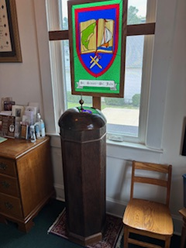
New Lid for the Baptismal Font! Clemens Von Claparède-Crola was kind enough to work on a lid for our baptismal font that matches the “pillar” portion that we have had for years. He used several different kinds of wood and fused them together and then shaped it. Wonderful job Clemens!
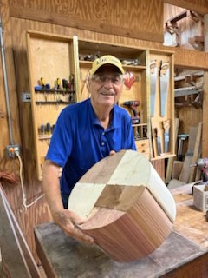

News and Information
Sept. 7: Start of Sunday School.
Sept. 12-13: DMAS Men’s Retreat.
Sept. 17: Vestry Meeting, 7:30 PM. Mass at 7 PM.
Oct. 1: Mass for St. Michael & All Angels, 6 PM.
Oct. 29: Mass for Ss. Simon & Jude, 6 PM.

DECEMBER, 2023
SUNDAY |  | MONDAY | TUESDAY | WEDNESDAY | THURSDAY |  | FRIDAY | SATURDAY
LEGEND: HC - Holy Communion; FHE – Festal Holy Eucharist; HE - Holy Eucharist; SS – Sunday School; PG - Prayer Group; EP – Evening Prayer; MP – Morning Prayer; P&HU – Prayers and Holy Unction |  |  |  |  |  | [1] |  | [2]  5:00 p.m. HC
[3]  8:00 a.m. MP & HC  10:00 a.m. HE, SS  ADVENT I |  | [4] | [5] | [6]  6:00 p.m. Poem study  7:00 p.m. HC  7:30 p.m. Vestry | [7]  12 noon HC | [8] |  | [9]  5:00 p.m. HC
[10]  8:00 a.m. MP & HC  10:00 a.m. HE  Annual Meeting  ADVENT II |  | [11] | [12] | [13]  6:00 p.m. HC | [14]  12 noon HC | [15] |  | [16]  1-4 p.m. (tent.) Santa  5:00 p.m. HC
[17]  8:00 a.m. MP & HC  10:00 a.m. HE, SS  ADVENT III |  | [18] | [19] | [20]  6:00 p.m. HC | [21]  12 noon HC | [22] |  | [23]  5:00 p.m. Advent lessons and carols
[24]  8:00 a.m. MP & HC  10:00 a.m. HE, SS  6:00 p.m. Family service  10:30 p.m. Carols  11:00 p.m. FHE  ADVENT IV  CHRISTMAS EVE |  | [25]  10:00 a.m. Matins and  HC  CHRISTMAS DAY | [26]  12 noon HC  ST. STEPHEN’S  DAY | [27]  6:00 p.m. HC  ST. JOHN  EVANGELIST | [28]  12 noon HC  HOLY INNOCENTS | [29] |  | [30]  5:00 p.m. HC

IN THE LORD’S SERVICE
If you cannot fulfill your assigned duty because of an urgent reason, PLEASE SECURE A REPLACEMENT.

 | December 3 | December 10 | December 17 | December 24 | December 31
Coffee Hour | V. Williams | C. Pappas | M. Slayton | E. Paisley | Volunteer needed
Epistoler 8 a.m. | D. Drysdale | C. Von Claparede | G. Mauney | D. Drysdale | C. Von Claparede
Epistoler 10 a.m. | P. Williams | T. Paisley | G. Terrell | P. Williams | T. Paisley
Altar servers and ushers will be assigned as available before each service.
2023 Vestry (term end): Dan Drysdale (’23), George Mauney (’25), Lisa Olver (’24),
Ted Paisley (’24), Mike Slayton (’25), Phil Williams (’23)

